ATTENDANCE MARKING FOR CLASSROOM

SRINITHI.S (15D241)

Dissertation submitted in partial fulfillment of the requirements for the degree of

bachelor OF ENGINEERING

Branch: BIOMEDICAL ENGINEERING

of Anna University, Chennai



APRIL 2019

DEPARTMENT OF BIOMEDICAL ENGINEERING

PSG COLLEGE OF TECHNOLOGY
(Autonomous Institution)

COIMBATORE- 641004

PSG COLLEGE OF TECHNOLOGY
(Autonomous Institution)

COIMBATORE- 641004

ATTENDANCE MARKING FOR CLASSROOM

SRINITHI.S (15D241)

Dissertation submitted in partial fulfillment of the requirements for the degree of

bachelor OF ENGINEERING
Branch: BIOMEDICAL ENGINEERING
of Anna University, Chennai
APRIL 2019

...………….. ……………... ………………… Ms.P.Prema Mr.M.Vigneshwaran Dr.R.VIDHYAPRIYA
Faculty guide External Guide Head of the Department

Certified that the candidate was examined in the viva-voice examination held on . . . . . . . . . . . . . . .

...……………………… ………………………
(Internal Examiner) (External Examiner)
CONTENTS

CHAPTER PAGE

ACKNOWLEDGEMENT……………………………………………..…. (i)

ABSTRACT……………………………………………………………….. (ii)

LIST OF FIGURES………………………………………………………. (iii)

LIST OF ABBREVIATIONS…………………………………………….. (iv)

1. INTRODUCTION……………………………………………………….. 1

2. LITERATURE SURVEY……………………………………………….. 4

3. METHODOLOGY………………………………………………………. 8

3.1 METHODOLOGY
3.1.1 Technologies Used
3.1.1.1 Java 8
3.1.1.2 JavaScript 10
3.1.1.3 Servlet 10
3.1.1.4 HTML5 11
3.1.1.5 CSS3 12
3.1.1.6 MYSQL 12
3.1.2 System Analysis –Existing System 12
3.1.3 Proposed methodology 14

3.2 SYSTEM DESIGN
3.2.1 Data Flow Diagram 16
3.2.2 Use Case Diagram 17
3.2.3 Database Design Process 20
3.2.4 Detailed Flow Graph 22

3.3 SOFTWARE REQUIREMENTS
3.3.1 MySQL Workbench 23
3.3.2 Eclipse IDE 24
3.3.3 Tomcat Server 26

4. RESULTS AND DISCUSSIONS…………………………………………… 27

4.1 IMPLEMENTATION
4.1.1 User Registration 27
4.1.2 User Authentication 28
4.1.3 Switch to classroom or web-ex session 31
4.1.4 Attendance marking for classroom session 32
4.1.5 Trigger feedback 34
4.2 TESTING
4.2.1 J Unit Mockito Testing 37

5. CONCLUSION…………………………………………………………… 38
6. BIBLIOGRAPHY………………………………………………………… 39

ACKNOWLEDGEMENT

I wish to convey my sincere gratitude to Dr.R.Rudramoorthy, Principal, PSG College of Technology, Coimbatore, for providing an opportunity to carry out this project work.

I would like to express my thankfulness to Dr.R.Vidhyapriya, Head of the Department, Biomedical Engineering, for her valuable and constructive suggestions during the development of this work.

I would like to thank my Project Guide Ms.P.Prema, Assistant Professor (Sl. Gr), Department of Biomedical Engineering, for her patient guidance, continuous support and encouragement and useful critiques of this valuable work.

I would like to convey my sincere gratitude to Mrs.V.Vijayalakshmi, Corporate Trainer, for providing me valuable suggestions and for guiding me in the development of the project.

I would like to honor my Programme Coordinator Dr.B.Padmapriya, Associate Professor, Department of Biomedical Engineering, for her patient guidance and useful critiques of this valuable work.

My sincere thanks to my Tutor, Ms.P.Prema, Assistant Professor (Sl.Gr), Department of Biomedical Engineering, for her continuous support and encouragement.

And last, but not least, I would like to thank God for the never- ending and wisdom to carry out this project.

SYNOPSIS

Over the years the manual attendance system has been carried across most of instructional establishments. To beat the matter of manual attendance, currently we have a tendency to square the measure of employing a net based mostly data management system, which might be enforced on any laptop. This method is being developed to take care of easy accessibility of data from the information. The applying thus makes use of MYSQL as backside and JAVA, HTML, CSS is employed as front end tool. It tracks all the main points of a student data associated with the course. The standard methodology of taking attendance by vocation names or sign language is incredibly time intense and are prone to errors. Here we have a tendency to implement a system that facilitate the admin to look at the absentees and stay a tab on absence.
The project work is towards the design and development of Attendance Marking system for classroom. This software will be convenient and user friendly.

LIST OF FIGURES
S.NO | FIG.NO | NAME OF THE FIGURE | PAGE NO
1 | 1.1 | Web Application Architecture | 1
2 | 3.1 | JVM vs JRE vs JDK | 9
3 | 3.2 | Java Execution Flow | 10
4 | 3.3 | Servlet Execution Flow | 11
5 | 3.4 | Functional Flow of Proposed Methodology | 15
6 | 3.5 | Entity relationship diagram for Attendance Marking System for Classroom | 17
7 | 3.6 | User Flow Sequence Diagram | 18
8 | 3.7 | Admin Flow Sequence diagram | 19
9 | 3.8 | Sequence diagram for attendance marking for classroom system | 20
10 | 3.9 | Entity relationship tables for Attendance Marking System for Classroom | 21
11 | 3.10 | User Detailed Flow Graph | 22
12 | 3.11 | Admin Detailed Flow Graph | 23
13 | 3.12 | MYSQL Workbench | 24
14 | 3.13 | Eclipse IDE platform | 25
15 | 3.14 | Tomcat Server Flow | 26
16 | 4.1 | User login page | 27
17 | 4.2 | User Registration page | 28
18 | 4.3 | User Login Authentication | 29
19 | 4.4 | User Registration Authentication | 30
20 | 4.5 | User registration authentication | 30
21 | 4.6 | Session page | 31
22 | 4.7 | Admin Session page | 31
23 | 4.8 | Course Details | 32
24 | 4.9 | Course Allocation | 32
25 | 4.10 | Attendance Marking for Classroom | 33
26 | 4.11 | Attendance pop up message | 33
27 | 4.12 | Admin Classroom or web-ex session | 34
28 | 4.13 | Registration table | 34
29 | 4.14 | Absentees page | 35
30 | 4.15 | Feedback page | 36
31 | 4.16 | Leave form page | 36
32 | 4.17 | J unit Test | 37

LIST OF ABBREVIATIONS

AMFC – Attendance Marking for Classroom
CSS – Cascading Style Sheet
DBMS – Database Management System.
DFD – Data Flow Diagram.
ERD -- Entity Relationship Diagram
GUI – Graphical User Interface.
HTML – Hyper Text mark up Language.
IDE – Integrated Development Environment.
JDK – Java Development Kit.
JRE – Java Runtime Environment.
JSP -- Java Server Page
JVM – Java Virtual Machine.
LAMP – Linux ,Apache, MySQL, Perl/PHP/Python.
OS – Operating System.
RDBMS – Relational Database Management System.
SDK – Software Development Kit.
SQL – Structured Query Language.
UI – User Interface.
UOD – Universe of Discourse.
WORA – Write Once Run Anywhere.

CHAPTER 1
Introduction
Attendance marking for classroom system (AMFS) is a package developed for daily attendance marking of scholars. Previously, the school relied heavily on paper records. This project focuses on preventing data in a straight forward approach and intelligible manner that reduces paper and time. The system is absolutely controlled by administrator concerning the student or user profile. The administrator will read the scholar attending report. The admin may also send feedback type to the scholar performance. Hence here communication is formed easier with the student or user with the admin. The aim of developing this package is to computerize the tradition approach of taking attendance. Another purpose of the package is to get the report mechanically at the end of the session [1].

This system provides a simple interface for the maintenance of student information. To maintain the records easily it can be used by any educational institution. Achieving this objective is difficult using a manual system as the information is scattered, can be redundant and collecting relevant information may be very time consuming. All these problems are solved using online attendance marking for classroom system [2].

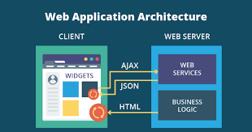

Fig. 1.1 Web Application Architecture

A web application (or "web app" for short) is any malicious program that performs a selected perform by using a web browser as its client. The applying is often as easy as a message board or a contact kind on a website or as advanced as an application program or a multi-player mobile gaming app that you just transfer to your phone. Most internet applications are based on the client-server architecture where the client enters the data whereas the server stores and retrieves the data. Net mail is an example of this, with corporations like Google's Gmail and Microsoft's Outlook giving web-based email clients [3]. The Web Application Architecture is shown in Figure 1.1
There are numerous steps in the web architecture and advancement process. From gathering initial information, to the production of your web site, and lastly to support to stay up with the latest and the current. The accurate process will vary slightly from architect to the creator, but the basics are the same.
- Information Gathering
- Planning
- Design
- Development
- Testing and Delivery
- Maintenance
The main objective of developing this system is to develop an automated way to keep track of attendance which would reduce the present pen and paper based method of marking attendance. Replacing the old method, this system will save time, reduce the amount of work and will replace the stationery material with a new standardized computer based system.
The system being developed is economic with respect to School or College’s point of view. It is cost effective since it has eliminated the paper work completely. The system developed contains minimum errors and are highly accurate as the data is required. Since it does not use additional hardware and software it is economic. The system working is quite easy to use and learn due to its simple but attractive interface. User requires no special training to operate the system [4].

The project work is towards the development of an Attendance Marking for Classroom System. Considering the user benefit as primary goal the device is designed to be user friendly.

This report work contains the list of journals and papers referred to pursue this project. The existing and proposed methodology are discussed. The system design and analysis is discussed and the technologies used to build the system is discussed here. The results obtained and future scope of this project work are explained.

CHAPTER 2
LITERATURE SURVEY

This chapter provides the basic technical knowledge and understanding regarding the Attendance Marking for Classroom System. A review on some of the prominent work on the technologies used and future works are present in the following section.

Visar Shehu et al proposed another methodology in the design of automatic attendance management systems, reached out with computer vision algorithms and calculations, where a continuous face location calculations were incorporated on to a current Learning Management System (LMS), which consequently distinguishes and enlists understudies going to on a course. This framework speaks to a supplemental device for educators, joining calculations utilized in AI with versatile techniques used to follow the facial changes amid a more drawn out timeframe. This new framework expects to be less tedious than customary strategies, in the meantime being nonintrusive and does not meddle with the standard educating process.

S.R.Bharamagoudar et al presented a simple interface for maintenance of student information. The creation and management of accurate, up-to-date information regarding a student’s academic career is vital. Accomplishing this goal is troublesome utilizing a manual framework as the data is dissipated, can be repetitive and gathering important data might be very tedious. Every one of these issues are understood utilizing on the web understudy data the board framework. The paper centers around displaying data in a simple and coherent way which gives facilities like online enrollment and profile production of students or user along these reducing paper work and robotizing the record age process in an instructive foundation.

Zhibing Liu et al studied the student information management system realization including production and maintenance of the database and front-end application development. This paper portrays the framework practical and engineering plan, and stresses the framework's usefulness, database structure and useful modules. It demonstrates that a completely utilitarian, adaptable and advantageous application and well-disposed interface give a decent certification to understudy data the executives.

V. Ramesh et al presented a paper where the extent of the paper is to recognize the factors impacting the performance of students in final examinations and find out a reasonable information mining calculation to predict the result of students so as to a give proper cautioning to students those who are in danger. In the present examination, an overview cum exploratory technique was received to produce a database and it was developed from an essential and an optional source. This work will assist the instructive organizations with identifying the students who are in danger and to give better extra preparing to the powerless students.

E. Rekha et al presented the paper where the target of the paper is to computerize the participation framework by incorporating the face acknowledgment innovation utilizing Eigen Face database and PCA calculation with Matlab GUI. In Conventional attendance framework there are few issues like fake attendance marking, lot of time utilization, manipulation of attendance, data cannot be secure and are prone to errors. There are numerous impediments in implementing face recognition technologies like Image Quality, Image Size, Face angle, varying intensity of light. In order to overcome these issues various techniques like Illumination Invariant, Histogram equalization, PCA are used. So as to defeat these issues different methods like Illumination Invariant, Histogram evening out, PCA are utilized. By utilizing this framework participation is refreshed consequently in the wake of contrasting the recognized face and unique Eigen database in Excel sheet incorporated with Matlab GUI.

Dr. Mohd Maqsood Ali presents the role of data mining in education sector. We know that every university either public or private and its colleges enroll thousands of students into various courses or programs every year. During the time of enrollment, they collect the data about the students. Before using the data, we must understand the nature of data because data can be used for classifying and predicting the students’ behavior, performance, dropouts as well as teachers’ performance The results of this paper clarify the use of information mining in training division. Accordingly, we can utilize the different procedures of information mining in instruction field like as we are utilizing the information mining in industry or business. Information digging can be connected for characterizing and bunching understudy's attributes dependent on statistic, psychographic and conduct factors. Information mining can likewise be connected by utilizing in the event that standard.

R.B Kuriakose et al shows that the exploration has demonstrated that there is a high connection between high class participation and scholarly execution. Learning is a dynamic movement which is an endless supply of the earlier day. Accordingly, participation checking ought to be an indispensable piece of any establishment particularly a tertiary organization. The significant test that a facilitator has in observing participation is the sheer desk work and consequent managerial work that pursues the procedure on the off chance that it is done physically. Numerous procedures have been created to mechanize participation checking including the utilization of biometrics. These methods have their own qualities and shortcomings. The paper first thinks about the difficulties confronting manual participation checking. Besides it takes a gander at a portion of the conceivable answers for robotizing participation observing including RFID innovation. Thirdly it indicates how the equipment part is setup lastly it depicts how Java writing computer programs is utilized to make an important connection between the information gathered by the RFID equipment in order to mechanize the participation register.

G. Mahesh et al proposed an undertaking that includes research and overview to distinguish how utilization of cell phones at instruction foundations can be made under the control of experts and how 1000s of address hours can be spared in a year utilizing this gadget. We propose a portable application which will help establishment experts to control the students cell phones and participation will be taken by the students itself for sparing the season of gauging participation. Students will be compelled to run this application as their participation will be set apart through this application. This will likewise spare the address time to some expand and will decrease the odds of students stamping intermediary attendances.

M.A. Norasiah et al exhibits that the student data the executives framework is for the most part intended to fulfill the student related information needs. This is for the most part utilized by students so as to view and access the data with respect to school which includes warnings, situation subtleties, test timetables and so forth. Any school related data, for example, occasions, warnings, refreshing or erasing of any student records should be possible effectively and safely utilizing this electronic online framework. Administrator gives verified logins to every single area, for example, situation segment, test segment, workforce and furthermore to every single individual understudy.

CHAPTER 3
METHODOLOGY

The aim of the project is to reduce the manual load of marking attendance and to keep a track of the absentees. The existing methodology, proposed methodology and system design and analysis is discussed in this chapter.

3.1 METHODOLOGY
3.1.1 TECHNOLOGIES USED
3.1.1.1 JAVA
Java is a programming language that produces programming for numerous stage. Java was created in the mid-1990s by James A. Gosling, a previous PC researcher with Sun Microsystems. Java is a universally useful, simultaneous, class-based, object-situated PC programming language that is explicitly intended to have a couple of execution conditions as could reasonably be expected. It is proposed to let application designers WORA, implying that the code keeps running on one stage shouldn't be recompiled to keep running on another. Figure 3.1 represents the JDK JVM JRE pictorial illustration.
- Java Runtime Environment (JRE) which contains the pieces of the Java SE stage required to run Java programs and is planned for end clients. JRE = JVM + libraries to run Java Application.
- Java Development Kit (JDK) which is expected for programming designers and incorporates improvement devices, for example, the Java compiler, Javadoc, Jar, and a debugger. JDK= JRE+ apparatuses to create Java Application.
- Java Virtual Machine (JVM) is the virtual machine that runs the Java bytecodes. You get this bytecode by compiling the .java files into .class files. .class files contain the bytecodes understood by the JVM [5].
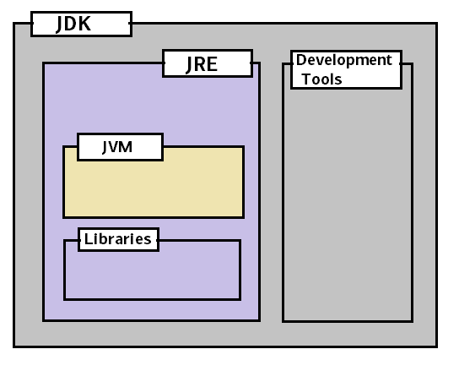
Fig 3.1 JVM vs JRE vs JDK

The flow diagram shown in Figure 3.2 represents the Java execution flow.
- We write the Java source code in Simple.java file using an editor or IDE e.g. Eclipse or IntelliJ Idea.
- Program has to be compiled into the bytecode. Java compiler (javac) compiles the source code to Simple.class file.
- This class file can be executed in any platform/OS by JVM
- JVM converts the bytecode into native machine code which the machines can execute [6].

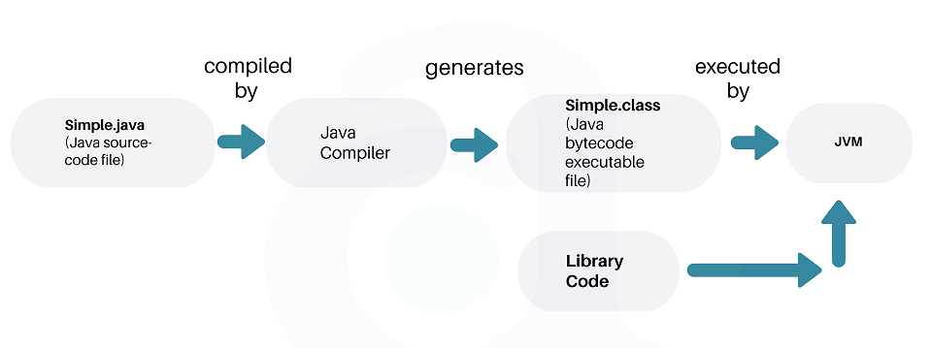
Fig 3.2 Java Execution Flow

3.1.1.2 JAVASCRIPT
JavaScript is viewed as a standout amongst the most well-known scripting dialects ever. JavaScript, by definition, is a scripting language of the world wide web. The primary utilization of JavaScript is to include different web functionalities, web structure approvals, program identifications, formation of treats, etc. JavaScript is a standout amongst the most famous scripting dialects and that is the reason it is supported by practically all internet browsers accessible today like Firefox. JavaScript is viewed as a standout amongst the most dominant scripting dialects being used today. Usually utilized for the advancement of client side web improvement. JavaScript is utilized to make website pages increasingly intelligent and dynamic. JavaScript is a light weight programming language and it is installed legitimately into the HTML code. JavaScript, as the name proposes, was affected by numerous dialects, particularly Java [7].

3.1.1.3 SERVLET
Servlets are Java programs that keeps running on Java empowered web server or application server. They are utilized to deal with the solicitation acquired from the web server, process the solicitation, produce the reaction, and after that send the reaction back to the web server. Servlets chip away at the server-side. Servlets are equipped for taking care of complex solicitation acquired from web server. Figure 3.3 shows the execution of servlets.

Execution of servlets includes the underneath six fundamental advances:
1. The customers send the solicitation to the web server.
2. The web server gets the solicitation.
3. The web server passes the solicitation to the relating servlet.
4. The servlet forms the solicitation and produce the reaction as yield.
5. The servlet sends the reaction back to the web server.
6. The web server sends the reaction back to the customer and the customer program shows it on the screen [8].

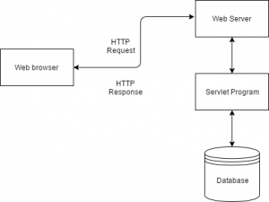

Fig 3.3 Servlet Execution Flow

3.1.1.4 HTML5
HTML5 is a programming language whose abbreviation represents Hyper Text Markup Language. It is a framework that permits the alteration of the presence of site pages, just as showing up. It likewise used to structure and present substance for the web. With HTML5, programs like Firefox, Chrome, Explorer, Safari and the sky is the limit from there, can realize how to show a specific website page, know where the components are, the place to put the pictures and where to put the content. The primary ideals of HTML5 over its forerunner (HTML4) is that you can include mixed media content without utilizing Flash or another media player. By utilizing HTML5, clients can get to sites without being associated with the Internet.

3.1.1.5 CSS3
CSS Stands for "Cascading Style Sheet." Cascading templates are utilized to organize the design of Web pages. They can be utilized to characterize content styles, table sizes, and different parts of Web pages that already must be characterized in a page's HTML. The fundamental motivation behind CSS is to isolate the substance of a web archive (written in any markup language) from its introduction (that is composed utilizing Cascading Style Sheets). There are heaps of advantages that one can extricate through CSS like improved substance openness, better adaptability and besides, CSS gives a dimension of authority over different introduction qualities of the report. It additionally helps in decreasing the multifaceted nature and aides in sparing generally introduction time. CSS gives the choice of choosing different style plans and standards as indicated by the necessities and it additionally permits a similar HTML record to be introduced in more than one changing style [9].

3.1.1.6 MYSQL
SQL represents Structured Query Language. SQL lets us to get to and control databases. SQL is an ANSI (American National Standards Institute) standard. SQL can execute questions against a database, recover information from a database, embed records in a database, update records in a database, erase records from a database, make new databases, make new tables in a database, make put away methods in a database, make sees in a database, set consents on tables, methodology, and perspectives [10].

3.1.2 SYSTEM ANALYSIS – EXISTING SYSTEM
The Existing system is a manual entry for the Admin and also for Users. Here the attendance will be carried out in the hand written registers. Maintaining the records for the Faculty is a tedious job. The retrieval of the information is not as easy as the records are maintained in the registers. This study provides a unique insight to computerization of attendance registration system with the exploitation of Waterfall Software Development Life Cycle technology. The development of this software originated from the importance of records of users' attendance that influences academic accomplishments in higher institutions of learning. The traditional way of storing and accumulating records is always liable to different degrees of difficulties in accessibility, safety, maintenance discrepancy, human errors and frauds. The recommended software overcomes the inadequacy challenges of the work-intensive manual system in registering user’s attendance records. In this application, MYSQL is used as back-end design, while Hypertext Markup Language, Bootstrap, Cascading Style Sheet, and JavaScript were exploited as front-end tools. The web system was connected with database of the records inherent in the remote server. The web system also allowed the application to be mobile-responsive, thereby making it easier to explore for both admin and the users. The application is not only secured, fast in process, very efficient and reliable, but also reduced pen and paper consumption in comparison with the unsecured manual approach [11].
The current framework has the accompanying burdens which will be overcomed in the proposed framework.
• Not User Friendly: The current framework isn't easy to use on the grounds that the recovery of information is extremely moderate and information isn't kept up productively.
• Difficulty in report creating: We require more estimations to produce the report so it is produced toward the finish of the session. What's more, the understudy not get a solitary opportunity to improve their participation
• Manual control: All computations to produce report is done physically so there is more noteworthy shot of mistakes.
• Lots of desk work: Existing framework requires part of administrative work. Loss of even a solitary register/record prompted troublesome circumstance since every one of the papers are expected to produce the reports.
• Time devouring: Every work is done physically so we can't produce report amidst the session or according to the prerequisite since it is very tedious [12].

3.1.3 PROPOSED METHODOLOGY
Attendance Management System is based on web server and web services which can be implemented on any computer. In this application, servlet is server side language, MySQL is used as back-end tool and HTML, CSS and JavaScript and bootstrap are used as front-end tools. The system communicates with database residing on a remote server. It calculates automatically, the attendance of user without any manual paper-based work. The system facilitates the end users with interactive design and automated processing of attendance management. In this application the user can register to the portal if he is a new user. The user can now login into the system, provided his/her details are previously authenticated in the database. The application now allows the user to choose the session (Classroom or web-ex sessions). Once the user selects his session, he is directed into a page where the user gets to mark his attendance. Once the user marks his attendance he gets a feedback form where he is given a form to rate his session and training experience. The next phase in this application is the admin phase where the admin logs into the system and he gets to view the page where he can check the status of user. Depending upon the status the user will get a notification of either a feedback form or a leave form. This application uses web services where each module can be deployed individually.

Attendance marking is mandatory for users. The manual attendance marking is also a very tedious process which involves a lot of paper work. The already existing web application has a fixed time for the users to login the system. In this model, the admin has the flexibility to fix the timing for the user to login the system. This helps in reducing the malpractices that occur during attendances. Moreover, the existing application does not use web services and micro services. Thus this proposed application reduces the complexity of the module and application. The characteristics or the advantages of the proposed methodology is discussed below

- User friendly: The proposed framework is easy to understand on the grounds that the recovery and putting away of information is quick and information is kept up productively. In addition, the graphical UI is given in the proposed framework, which gives client to bargain the framework in all respects effectively.
- Reports are effectively produced: Reports can be effectively created in the proposed framework so client can create the report according to the necessity.
- Very less desk work: The proposed framework requires extremely less administrative work. Every one of the information is feted into the PC quickly and reports can be created through PCs. Besides, work become simple in light of the fact that there is no compelling reason to keep information on papers. Figure 3.4 delineates the useful stream of proposed procedure [13].

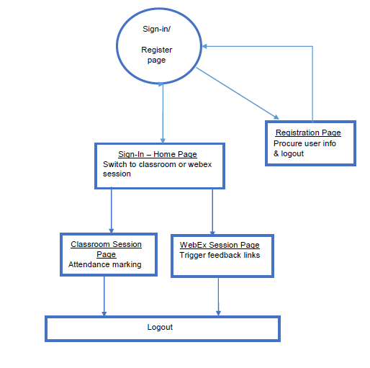

Fig 3.4 Functional Flow of Proposed Methodology

3.2 SYSTEM DESIGN
This deals with data flow diagram, detailed flow graph and the design process of the front and back end design of the attendance marking system for classroom.

3.2.1 DATA FLOW DIAGRAM
A Data Flow Diagram (DFD) is a graphical portrayal of the "stream" of participation stamping framework for study hall. An information stream graph can likewise be utilized for the representation of Data Processing. DFD demonstrates the connection between the framework and outside elements. This setting level DFD is then "detonated" to demonstrate more detail of the framework being displayed. A DFD speaks to stream of information through a framework. Information stream graphs are ordinarily utilized amid issue investigation. It sees a framework as capacity that changes the given contribution to required yield. An entity relationship diagram (ERD), otherwise called an entity relationship model, is a graphical portrayal of a data framework that delineates the connections among individuals, objects, spots, ideas or occasions inside that framework. An ERD is an information displaying method that can help characterize business forms and be utilized as the establishment for a social database. Development of information through the distinctive changes or procedures in the framework are appeared in element relationship chart of Fig 3.5. In Fig 3.5 the square shape image speaks to the substance which are articles or ideas that can have information put away about them, the oval image portrays the traits which are properties or attributes of elements. An ERD property can be meant as an essential key, which distinguishes an extraordinary quality, or an outside key, which can be allotted to various characteristics and the jewel image speaks to the relationship among the elements [14].

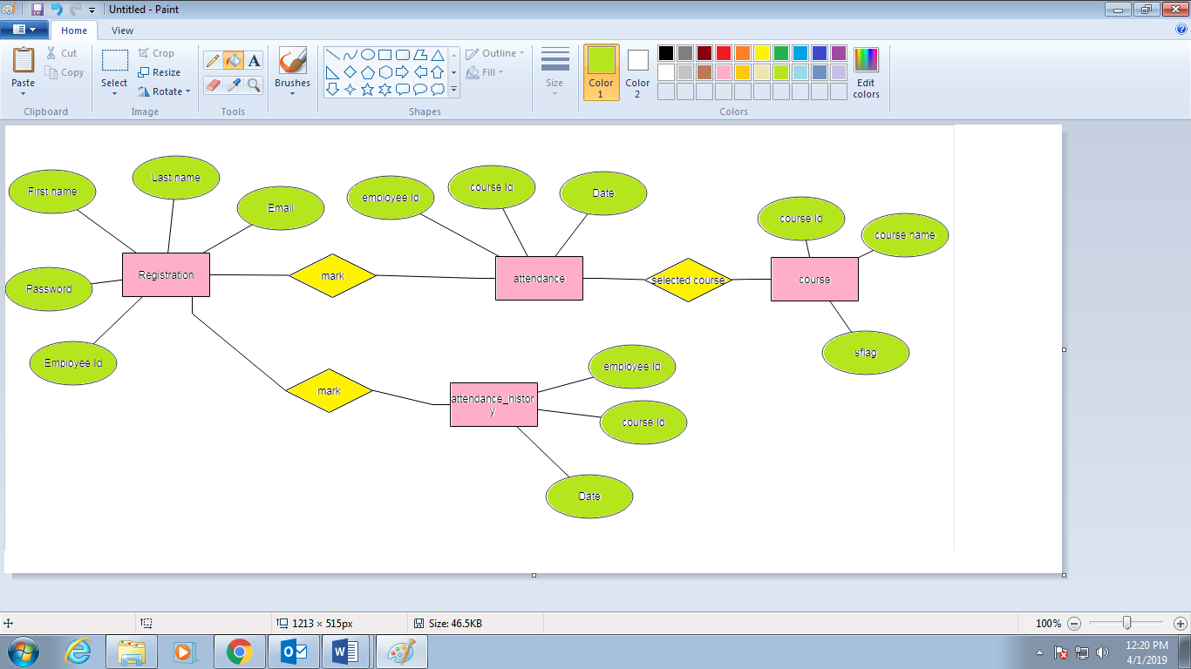

Fig 3.5 Entity relationship diagram for Attendance Marking System for Classroom

3.2.2 USE CASE DIAGRAM
Use Case Diagram is utilized to demonstrate situations utilized for understanding the prerequisites of the framework and to demonstrate the communication between the client and the framework [15]. Figure 3.6 depicts the user flow in the attendance marking system.

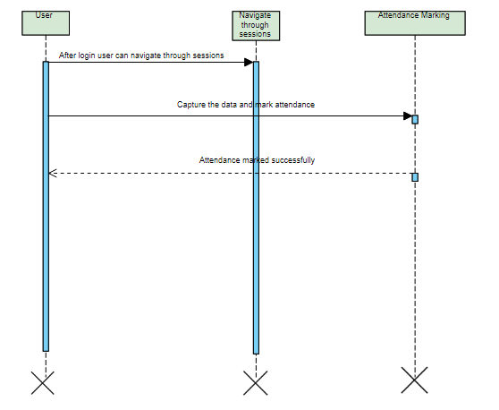
Fig 3.6 User flow sequence diagram

The ‘user’ here shall be the operator of the system and will be keying in the attendance information into the system. After login the user must be able to navigate through classroom or web-ex sessions. A registered user is able to click ‘Login’ link, after keying in ‘Employee ID’ & ‘Password’ field and get his credentials authenticated with the existing database entry. If the registered user is unable to get his credentials authenticated, the user is presented with relevant error messages:

- Invalid Employee ID – The employee-id provided does not exist in our records
- Invalid Password – ‘Password provided is incorrect and does not match with our records.
Once the user is logged in he/she will be able to navigate through sessions either classroom or web-ex session. The user has to capture the data and mark the attendance accordingly. Figure 3.7 depicts the admin flow in the attendance marking system.

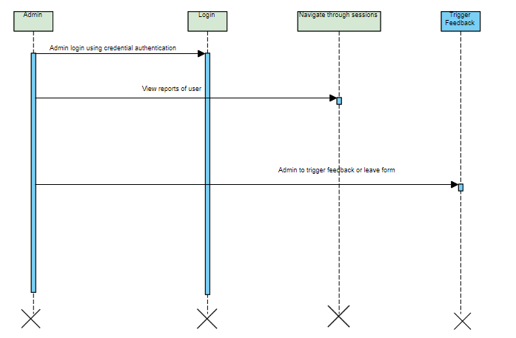
Fig 3.7 Admin flow sequence diagram

The ‘admin’ will be the operator of the system and will be allowed to trigger feedback either feedback or leave form. A registered admin – is able click ‘Login’ link, after keying in ‘Employee ID’ & ‘Password’ field and get his credentials authenticated with the existing database entry. The admin has the ability to view the reports of the user and can navigate through sessions. Based on the presence or absence of the user the admin will be able to trigger either feedback or leave form. Figure 3.8 depicts the overall sequence diagram for attendance marking system.

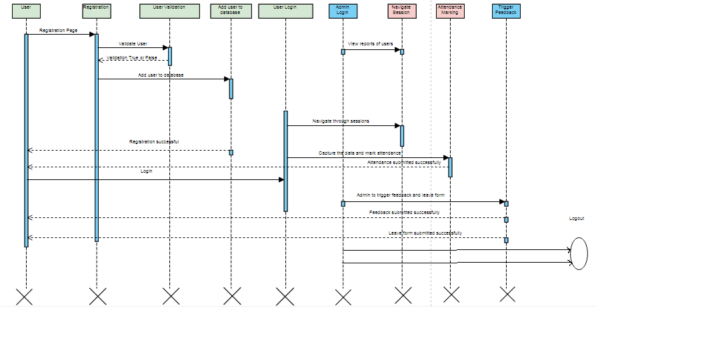
Fig 3.8 Sequence diagram for attendance marking for classroom system

When a new user clicks on the registration link, he/she shall be re-directed to the registration form where the user needs to fill in some of the basic attributes/fields as mentioned below in requirement: First Name, Last Name, Employee Id, Email, Password on clicking ‘Submit’ the datatype constraints will be validated for each field. Post-successful field level validation, the information will be saved in the database. A registered user – is able click ‘Login’ link, after keying in ‘Employee Id & ‘Password’ field will get his credentials authenticated with the existing database entry. Logged in user can choose to navigate either to classroom session or WebEx session. System to capture the logged in user data and save the details in the database to mark their attendance accordingly. The Admin profile will be allowed to generate reports with the list of associates present/absent for the sessions. Based on the presence or absence of the users the admin will trigger either a feedback form or a leave form [6].

3.2.3 DATABASE DESIGN PROCESS
Database play a critical role in almost all areas where computers are used, including business, electronic commerce, engineering, medicine, law, education, and library science. A database is collection of a related data [16]. Fig 3.9 depicts the entity relationship table for attendance marking for classroom system

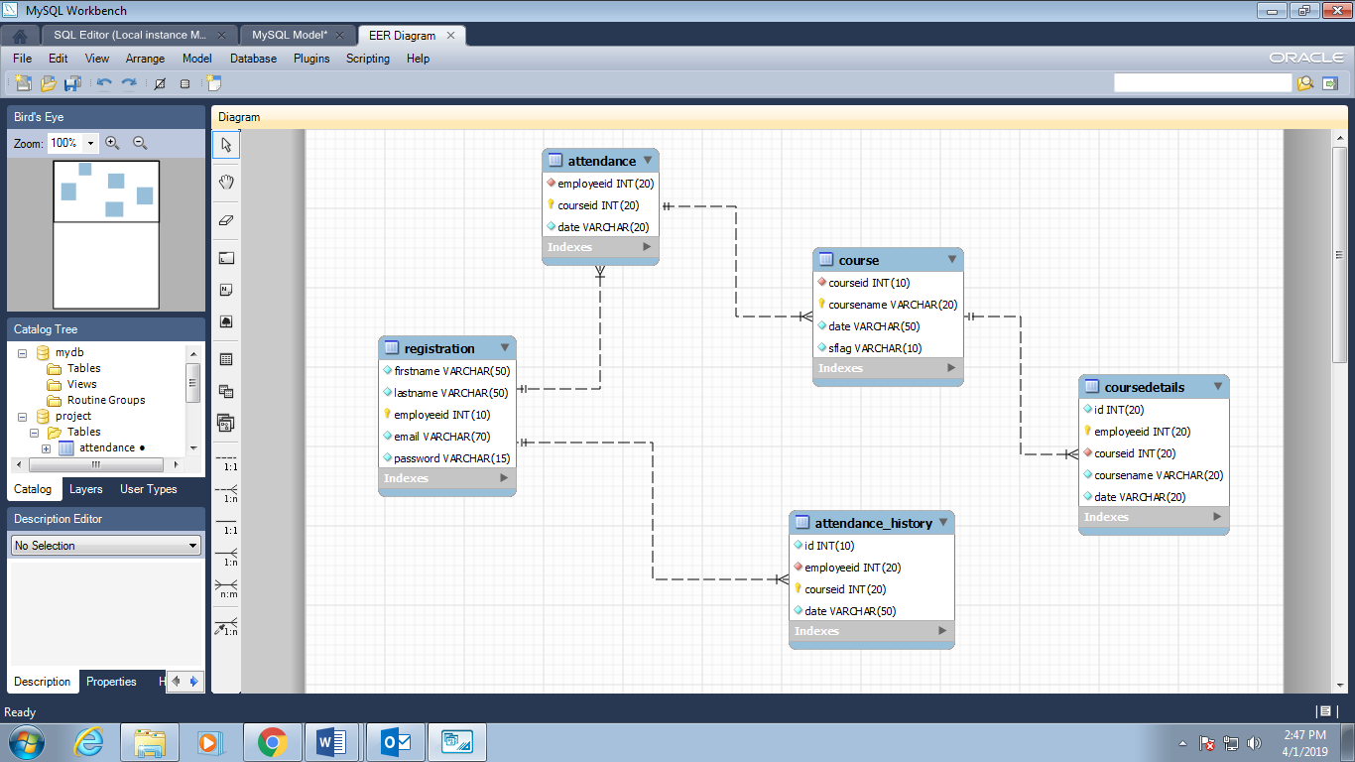

Fig 3.9 Entity relationship tables for Attendance Marking System for Classroom

A database has the accompanying understood properties:
• A database speaks to some part of this present reality, some of the time called the smaller than expected world or the Universe of Discourse (UOD) changes to the scaled down world are reflected in the database
• A database is a consistently sound accumulation of information with some inborn significance. An irregular variety of information can't accurately be alluded to as a database.
• A database is planned, assembled, and populated with information for a particular reason. It is a proposed gathering of clients and some biased application which these clients are intrigued.
In figure 3.9 different tables related to attendance marking system were created and constraints such as primary and foreign key constraints were given. Defining a database involves the specifying the data types, structures, and constraints of the data to be stored in the database
Database Management System (DBMS) is a general – reason programming framework that encourages the way toward characterizing, building, controlling, and sharing database among different clients and applications. The database definition or clear data is likewise put away in the database as word reference; it is called meta information building the database is the way toward putting away the information on the capacity medium that is constrained by the DBMS [17].

3.2.4 DETAILED FLOW GRAPH
The function of the individual entities is explained in detail in the flow graph. Fig 3.10 depicts the user detailed flow in the attendance marking for classroom.

LOGIN

USER
CHOOSING THE SESSION

CAPTURE THE DATA AND MARK ATTENDANCE

Fig 3.10 User Detailed Flow Graph

USER: The user is the center focus because in every college user (student) plays the very important role. User can access the subjects either classroom course or web-ex course that is been allotted to them by the admin. The user can access the page only in a scheduled time i.e. the session time for example from 9 to 12. The course details include the course ID, course name and the date in which the course is being offered. Here the course is tentatively scheduled for one day and the user on clicking the attendance button will have access to the course lectures and videos. Here main aim is to keep track of absentees, to note down the absentees the user who have registered but have not marked attendance will be considered. Every ID and password for the user is unique and it is authenticated. Fig 3.11 depicts the admin detailed flow in the attendance marking for classroom.

UPDATE THE COURSE DETAILS TO THE USER

ADMIN
VIEW REPORTS

TRIGGER FEDBACK OR LEAVE FORM

Fig 3.11 Admin Detailed Flow Graph

ADMIN: The admin is unique here and there is only one admin with a unique ID and password. The admin is responsible for course allocation to the user and is able to generate reports of the user who are present or absent for the course. If a user is present for a particular course a feedback form will be triggered to the user by the admin, once the user fills the feedback form and submits it the user can again login to the system and choose the course. If a user fails to attend a course a leave form will be triggered to the user by the admin.

3.3 SOFTWARE REQUIREMENTS
3.3.1 MYSQL WORKBENCH
SQL represents Structured Query Language. MySQL is an open source RDBMS; it is a mainstream database for use in web applications, and is a focal piece of the extraordinarily utilized LAMP open-source web application programming stack. Various substantial scale sites including Google, YouTube, Facebook, Twitter, and Flickr are likewise utilizing MySQL. On all stages barring Windows, MySQL sends with no GUI to control MySQL databases or dealing with the information held inside the databases.
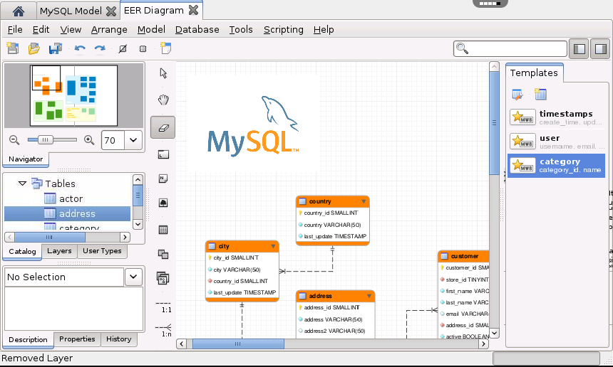
Fig 3.12 MYSQL Workbench

Clients may introduce MySQL Workbench appeared in Figure 3.12 by downloading independently or basically may utilize the direction line apparatuses. Quantities of outsider GUI devices are likewise accessible. Swedish organization has made MySQL which is written in C and C++. The main variant of MySQL uncovered on 23 may 1995. The general openness of MySQL 5.7 was communicated in Oct 2015, and the rendition which is utilized in my undertaking is 5.6.17 [18].

3.3.2 ECLIPSE IDE
Eclipse is a stage that has been planned starting from the earliest stage for structure coordinated web and application advancement tooling. By plan, the stage does not give a lot of end client usefulness without anyone else's input. The estimation of the stage is the thing that it energizes: quick improvement of coordinated highlights dependent on a module demonstrate. Eclipse gives a typical UI model to working with apparatuses. It is intended to keep running on various working frameworks while giving powerful combination each hidden OS. Modules can program to the Eclipse compact APIs and run unaltered on any of the bolstered working frameworks. It is an IDE and It is composed for the most part in Java so of course it is generally utilized for applications yet it might likewise be utilized to create applications in other programming dialects by means of modules, including: Ada, C, C++, Python, Ruby (counting Ruby on Rails system), and so forth. The Eclipse SDK, which incorporates the Java improvement instruments at first.

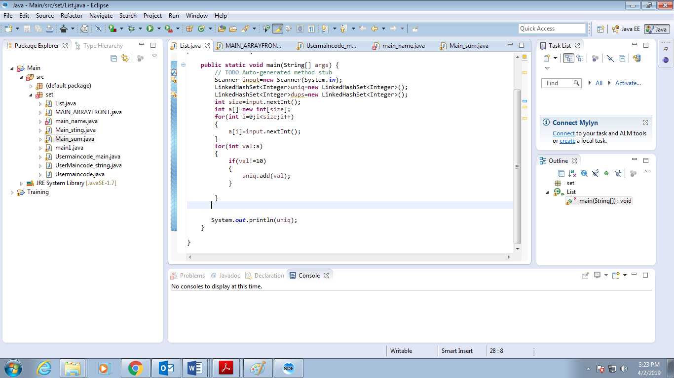
Fig 3.13 Eclipse IDE platform

Eclipse SDK shown in Figure 3.13 is free and open-source software, released under the terms of the Eclipse Public License, although it is incompatible with the General Public License.

3.3.3 TOMCAT SERVER
Apache Tomcat is an open source web server that is created by Apache programming establishment. It fundamentally makes our Java Web applications to keep running on host and server based framework and it is arranged on neighborhood have port 8080.It for the most part runs JSP, Servlet and so forth. There is a worked in web compartment called Catalina in the tomcat canister registry. It stacks all http related solicitation and has benefit to instantiate the GET and POST strategy's item. It likewise utilizes cynote for example a http connector through system layer of the PC. All the execution is overseen by JSP motor [19]. The Tomcat Server flow is shown in Figure 3.14.

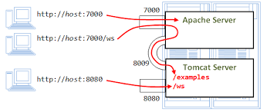
Fig 3.14 Tomcat Server Flow

CHAPTER 4
RESULTS AND DISCUSSION

This chapter includes the results and discussion on the design and development of Attendance Marking for Classroom System. The overall working of the system and the design is discussed below.
4.1 IMPLEMENTATION
4.1.1 USER REGISTRATION
The User is the operator the system. The fields required to login into the system is the employee ID or user Id and password. The login page is shown in Fig 4.1.

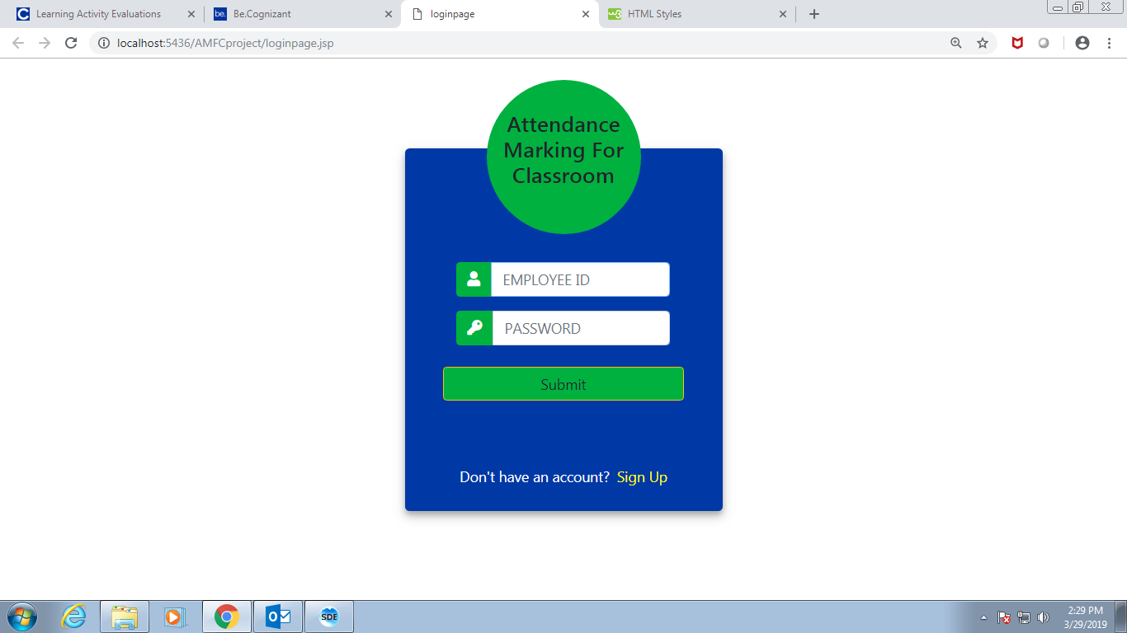
Fig 4.1 User Login page

When a user is new to the website and if he/she does not hold an account then the user has to register to the account. The registration page consists of fields such as their name, email ID, employee ID and password. The registration page is shown in Fig 4.2.

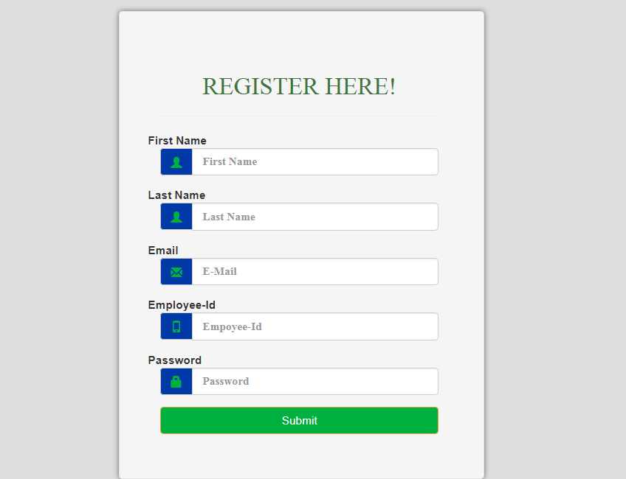
Fig 4.2 User Registration page

4.1.2 USER AUTHENTICATION

The fields have to be validated, that is once the data is being registered by the user and then if the user logs in into the system the data registered has to match with the data logged in so as to ensure that correct person has logged in into the system. The user login authentication page is shown in Fig 4.3. If the field is empty or if the field does not match with existing record it should throw an error.
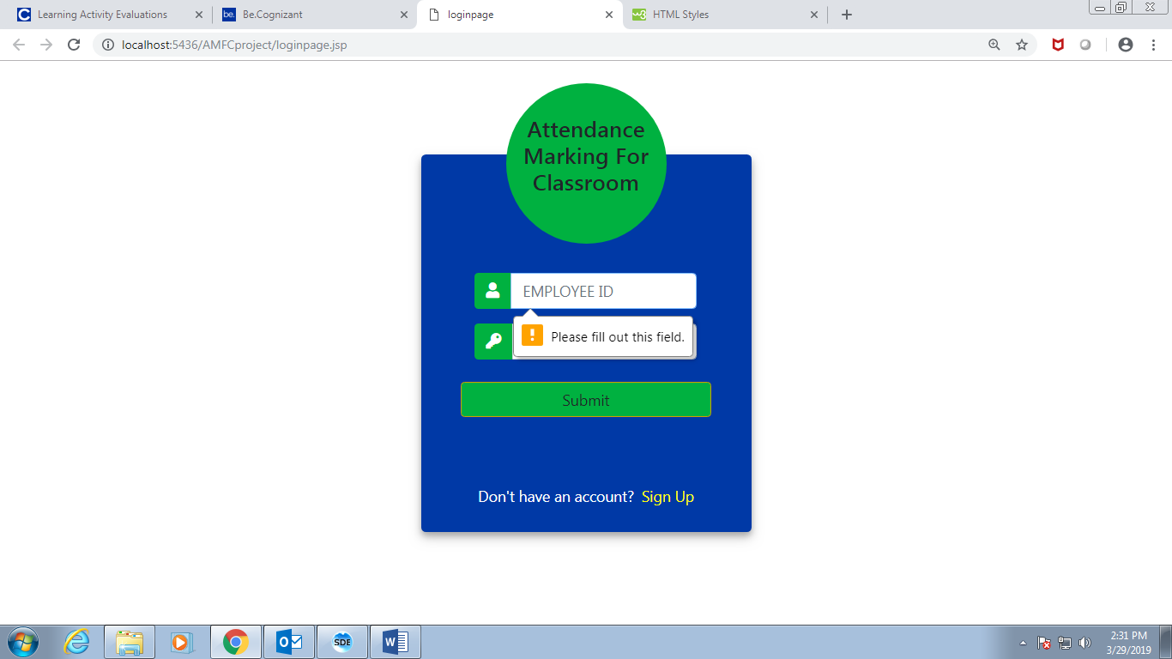
Fig 4.3 User Login Authentication

Fig 4.4 explains the user registration authentication. When the user creates the account the fields has to be validated. Figure 4.4 explains the basic email validation where ‘@’ symbol and ‘.’ symbol is required for correct email ID. If it does not match, then error message will be displayed.
Figure 4.5 explains the password validation where the password has to be 8 characters. If it does not match, then error message will be displayed.

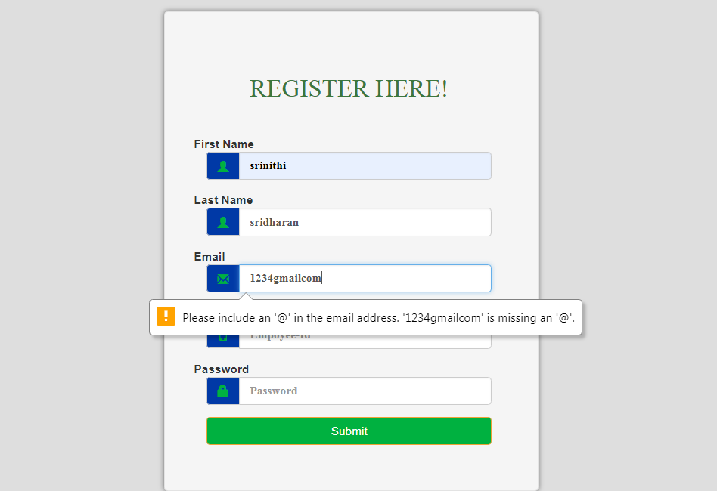
Fig 4.4 User Registration Authentication

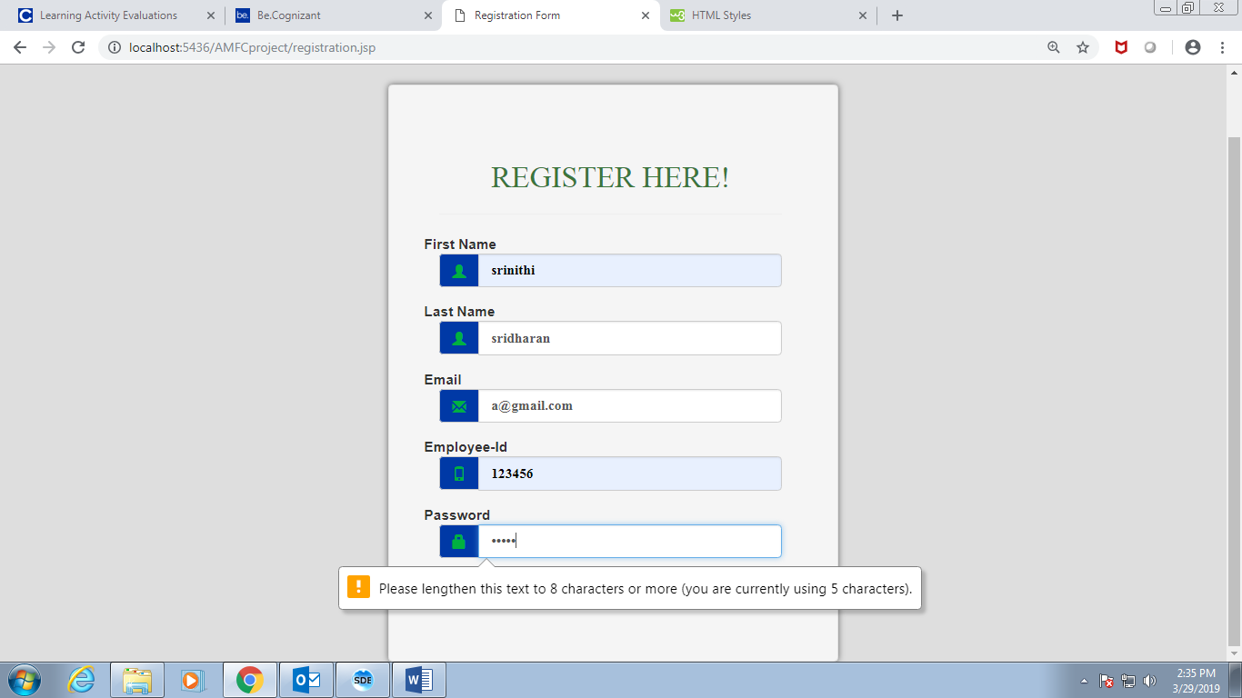
Fig.4.5 User registration authentication

4.1.3 SWITCH TO CLASSROOM OR WEB-EX SESSION

Once a user logs in into the system, the user has to navigate through either classroom or web-ex session where the user can view the course details being scheduled or allocated by the admin to the user. Figure 4.6 shows the session page and Figure 4.7 shows the admin session page.

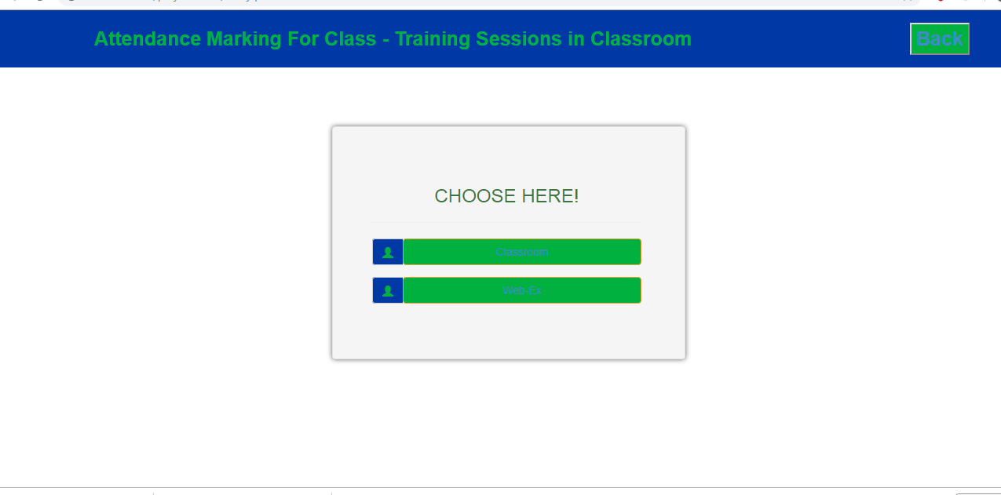
Fig. 4.6 Session page

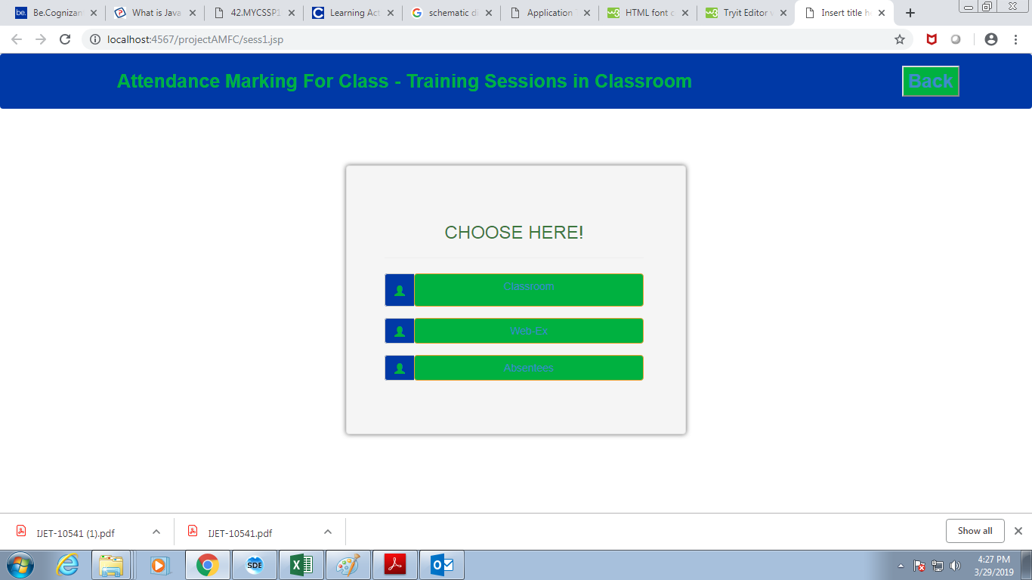
Fig. 4.7 Admin Session page

The admin has specific user ID and password where the admin only can schedule the course for the user. Once the admin logs in into the system the admin have the access to navigate through sessions and he/she can view the users who have chosen classroom or web-ex session and is present for the day and the list of absentees.

4.1.4 ATTENDANCE MARKING FOR CLASSROOM SESSION

The admin is responsible for allocating the course to the user. Figure 4.8 shows the list of course available.
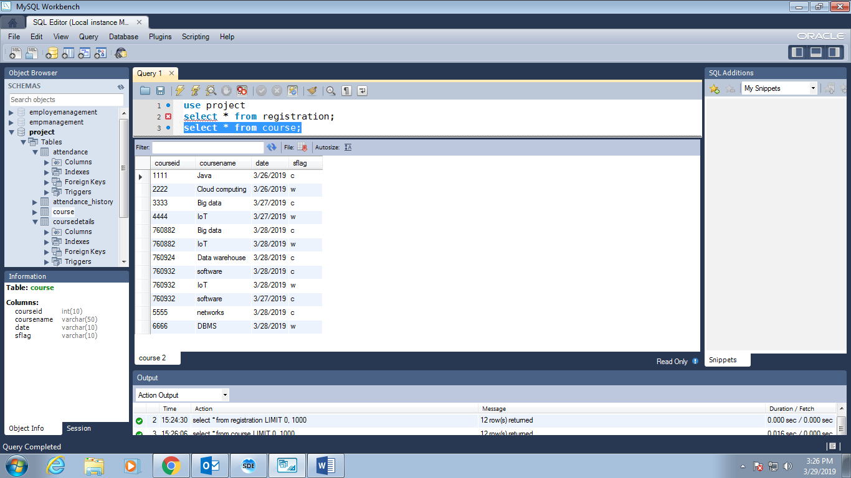
Fig. 4.8 Course Details

Figure 4.9 shows the course allocated to employee or user. The user or employee is allocated with classroom or web-ex course. Here the course is being considered for only one day and is allotted to user.

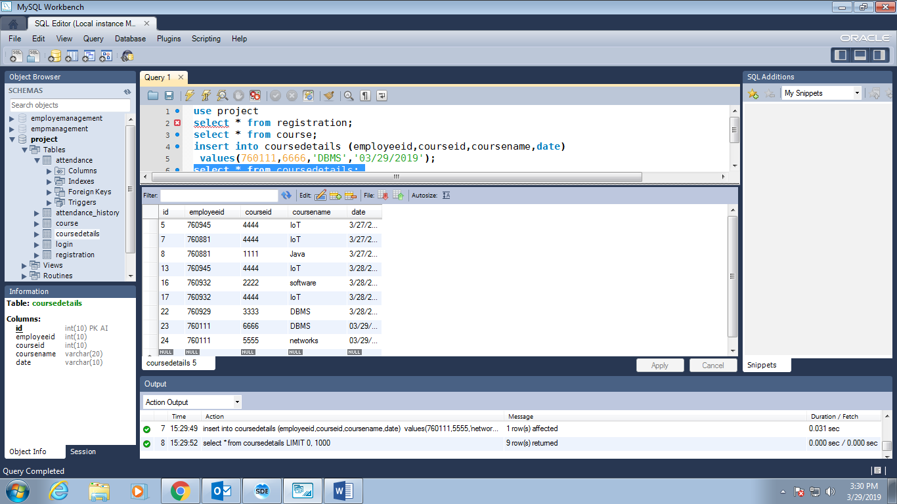
Fig. 4.9 Course Allocation
Here the user is the operator of the system and when the user logs in into the system the user can view the course allocated where the fields like employee id, course id, course name and a button like mark is displayed to show the user of the course that is allotted to him/her. Figure 4.10 shows the attendance marking for classroom session.

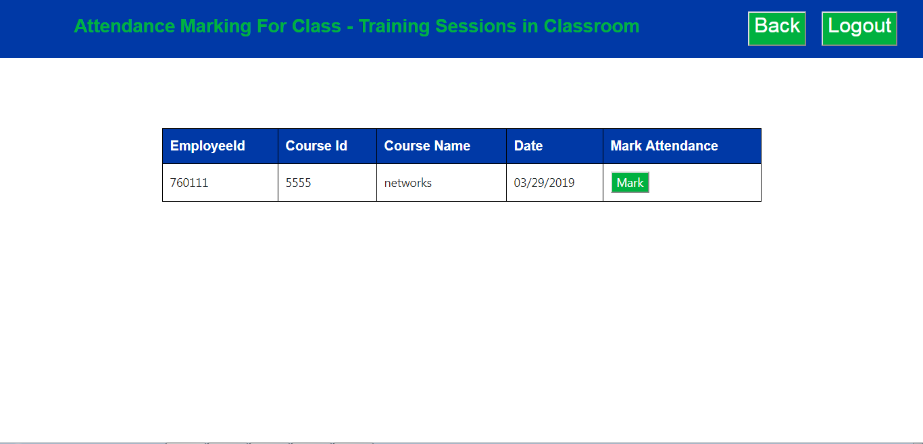
Fig. 4.10 Attendance Marking for Classroom

When the user presses the mark button a pop up message “ATTENDANCE MARKED SUCCESSFULLY” will be displayed as shown in Figure 4.11.

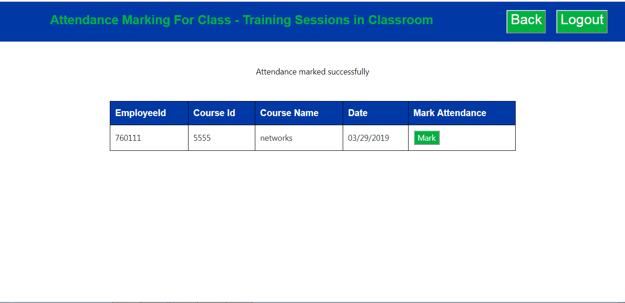
Fig. 4.11 Attendance pop up message

4.1.5 TRIGGER FEEDBACK

The admin is the operator of the system. When the admin chooses classroom or web-ex session then it is as shown in Figure 4.12 where when the admin presses send feedback button a pop up will be displayed and the aflag shown in Figure 4.13 changes to sf and if it for absentees the aflag changes to sr.
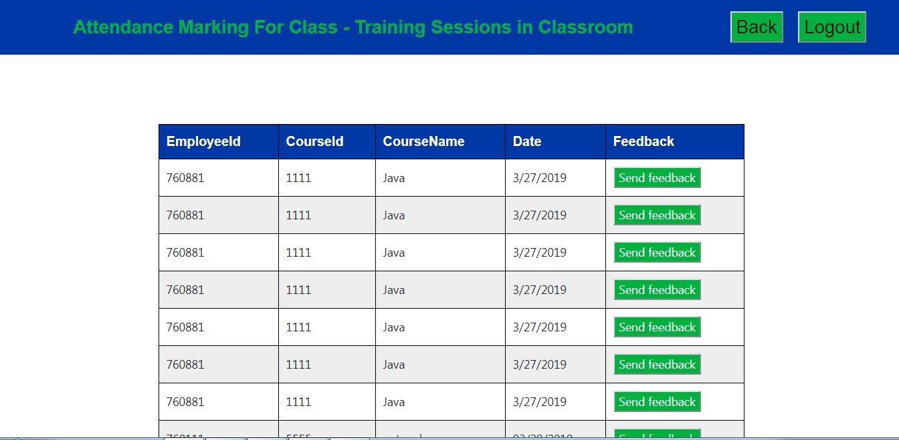
Fig. 4.12 Admin Classroom or web-ex session

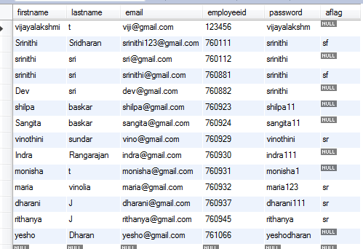
Figure 4.13 Registration table

By choosing the absentees page the admin can view the list of users as shown in Figure 4.14 who were absent for the session and can trigger a leave form to the user.

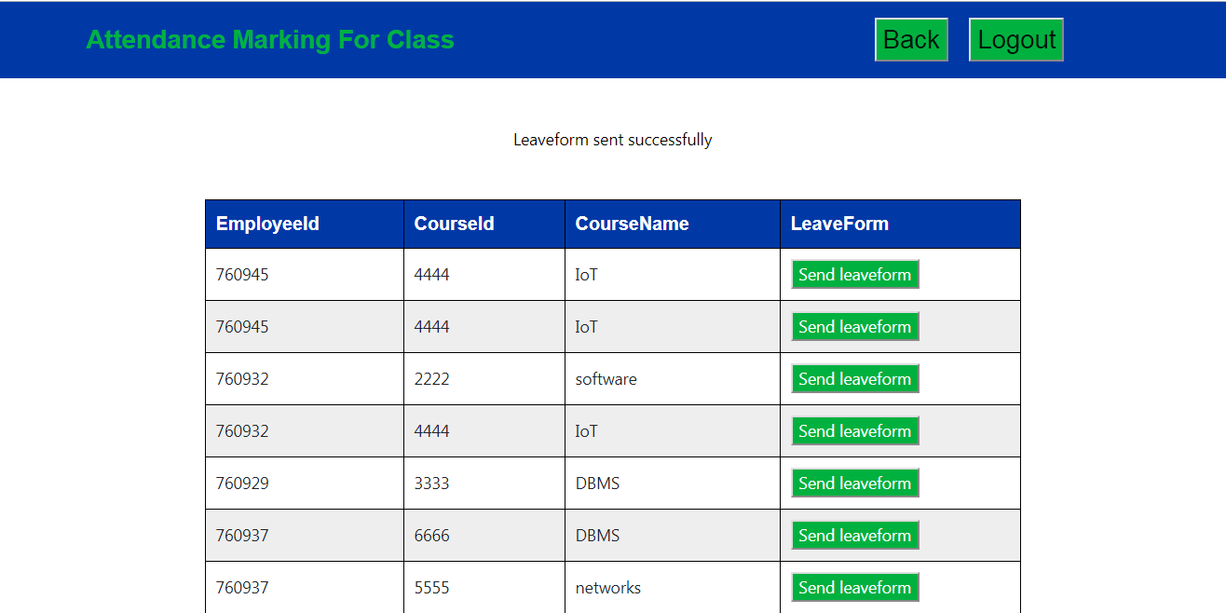
Figure 4.14 Absentees page

When the user is present for the session a feedback form as shown in Figure 4.15 is sent to the user that contain the list of questions to rate the training experience.
When the user is absent for the session a leave form as shown in Figure 4.16 is sent to the user that contain the list of questions to know the reason for absenteeism and to prevent the future occurrence.

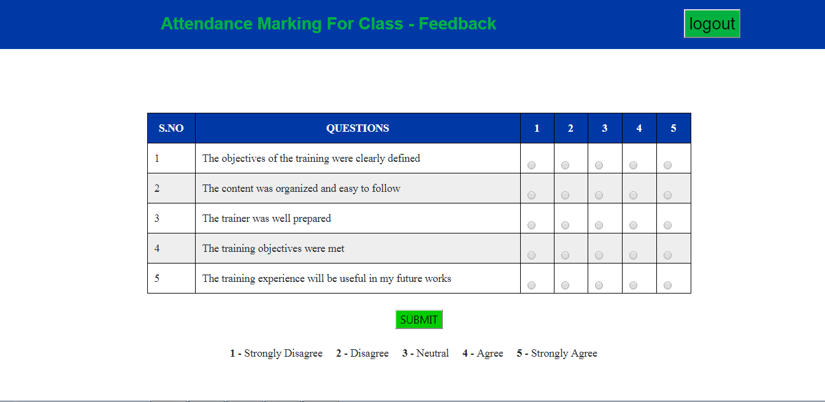
Figure 4.15 Feedback page

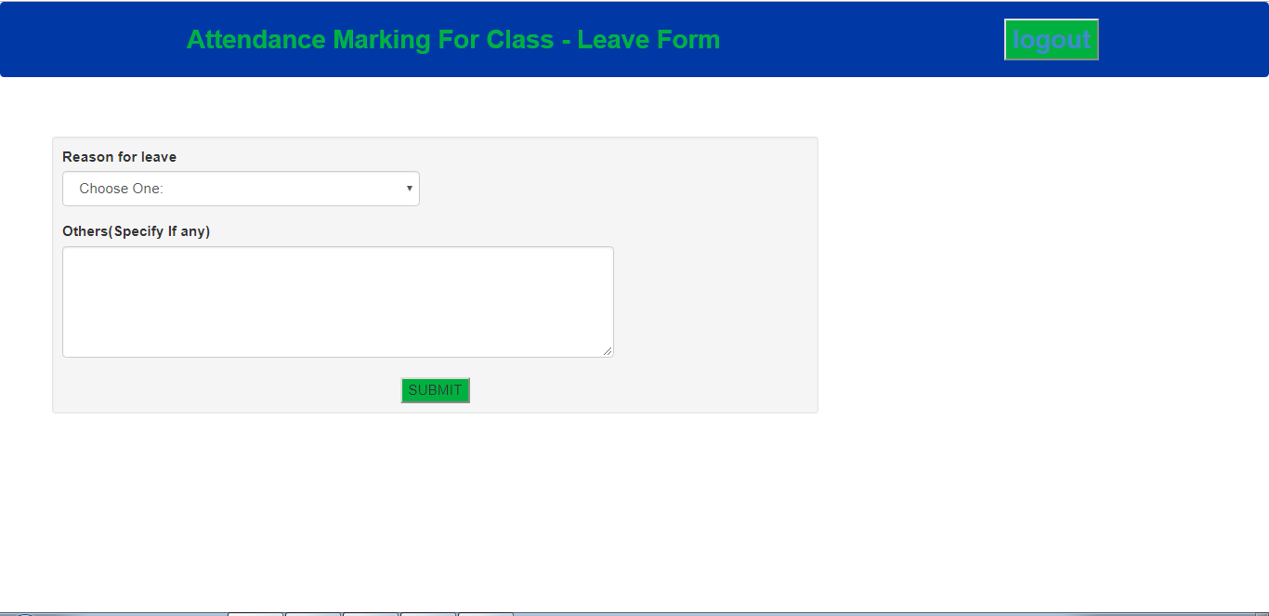
Figure 4.16 Leave form page

Once when the user fills the feedback or leave form and presses submit button then aflag shown in Figure 4.13 becomes null which shows that the course is over and again the user can login into the system and can take another course.

4.2 TESTING
4.2.1 J UNIT MOCKITO TESTING
JUnit is an ideal unit test system for Java programming language. Unit testing is a dimension of programming testing where singular units/segments of a product are tried. The reason for existing is to approve that every unit of the product executes as planned. A unit is the littlest testable piece of any product. It usually has one or a few inputs and usually a single output. Fig 4.17 shows a sample Mockito test done for the code and it shows in green which means the code written is correct.

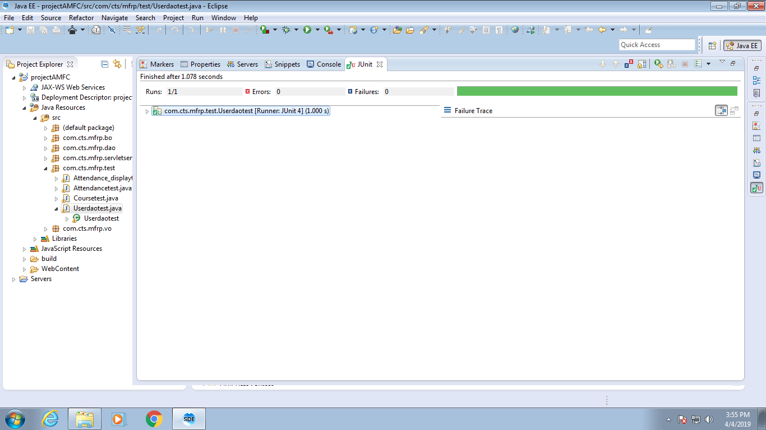
Figure 4.17 J unit Test
CHAPTER 5
CONCLUSION AND FUTURE WORK

The aim of the project is to develop automated Attendance Marking for Classroom system. The device is designed to be user friendly, technically feasible and justifiable. The system is designed using HTML5, CSS3 and JavaScript as front end tools and servlet as middleware and SQL server as backend tool. The system is tested and the results are obtained. Using Attendance marking for classroom system the user can eliminate the difficulties in the manual attendance. Till now the objective regarding both the user and admin flow is completed and analyzed.

FUTURE WORK

- Development of system for overall university consisting of large datasets
- To use micro services and to optimize the work
- Integrating deep learning to improve performance.
- Adding more features on to the system
- Using data mining for classifying student characteristics

BIBLIOGRAPHY

- V Shehu, A Dika “Using real time computer vision algorithms in automatic attendance management systems”, (ITI), 32nd International Conference on, 2010.

S.R.Bharamagoudar, Geeta R.B., S.G.Totad, ”Web Based Student Information Management System”,International Journal of Advanced Research in Computer and Communication Engineering,Vol. 2, Issue 6, June 2013.
- Zhibing Liu, Huixia Wang,Hui Zan “Design and implementation of student information management system.” 2010 International symposium on intelligence information processing and trusted computing. 978-0-7695- 4196-9/10 IEEE

V.Ramesh, P.Parkavi and K.Ramar, “Predicting student performance: A statistical and data mining approach,” International Journal of Computer Applications (IJCA), vol. 63-No.8,February 2013
- E. Rekha, P. Ramaprasad, "An efficient automated attendance management system based on Eigen Face recognition", 2017 7th International Conference on Cloud Computing Data Science & Engineering - Confluence, vol. 5, pp. 605-608, jan 2017.
- Dr.Mohd Maqsood Ali,”Role of data mining in education sector,” International Journal of Computer Science and Mobile Computing(IJCSMC),vol 2,issue 4,April 2013
- R.B. Kuriakose, H.J. Vermaak, "Developing a Java based RFID application to automate student attendance monitoring", Pattern Recognition Association of South Africa and Robotics and Mechatronics International Conference, pp. 48-53, 2015.
- G Mahesh, KR Jayahari, Kamal Bijlani, "A Smart Phone Integrated Smart Classroom", Next Generation Mobile Applications Services and Technologies, 2016.
- M.A. Norasiah and A. Norhayati. “Intelligent student information system”. 4th International conference on telecommunication technology proceedings, Shah Alam, Malaysia, 0-7803-7773-7/03 2003 IEEE.
- Z. Zhang, P. Gong, L. Cao, Y. Chen, "Design and Implementation of Educational Administration Attendance Management System Based on B/S and C/S", 2007 First IEEE International Symposium on Information Technologies and Applications in Education, pp. 606-609, 2007.
- M. Kassim, H. Mazlan, N. Zaini, M. K. Salleh, "Web-based student attendance system using RFID technology", 2012 IEEE Control and System Graduate Research Colloquium Shah Alam Selangor, pp. 213-218, 2012.
- M. Landin, J. Perez, "Class attendance and academic achievement of pharmacy students in a European University", Curr Pharm. Teach. Learn., vol. 7, no. 1, pp. 78-83, 2015.
- Jin Mei-shan1 Qiu Chang-li 2 Li Jing 3. “The Designment of student information management system based on B/S architecture”. 978-1- 4577-1415-3/12 2012 IEEE.
- G.Satyanarayana Reddy,Rallabandi Srinivasu,Srikanth Reddy Rikkula,Vuda Sreenivasa Rao,” Management Information System To Help Managers For Providing Decision Making In An Organization”, International Journal of Reviews in Computing, ISSN: 2076-3328, EISSN: 2076-3336
- P.Meena Kumari, SK.Abdul Nabi and Puppal Priyanka,”Educational data mining and its role in educational field,” International Journal of Computer Science and Information Technologies (IJCSIT),vol. 5(2),2014
- P.Veeramuthu and Dr.R.Periaswamy,“Application of higher education system for predicting student using data mining techniques,” International Journal of Innovative Research in Advanced Engineering(IJIRAE),vol. 1 issue 5,June 2014
- Ajay Kumar Pal & Saurabh Pal,“Data Mining Techniques in EDM for Predicting the Performance of Students”,2009
- Kumar, “An Empirical Study of the Applications of Data Mining Techniques in Higher Education”. IJACSA - International Journal of Advanced Computer Science and Applications, 2011
- Suchita Borkar & K. Rajeswari, “Predicting Students Academic Performance Using Education Data Mining”, IJCSMC, Vol. 2, Issue. 7, July 2013, pg.273 – 279

